**CSE 215L: Programming language II Lab**

**Faculty: Dr. Ziaul Hossain (ZHo)**

**Sec: 06**

**Lab - 03 [Control Statements-02, Characters, Strings], Spring-2021**

**Lab Instructor: Salsavil Kayyum**

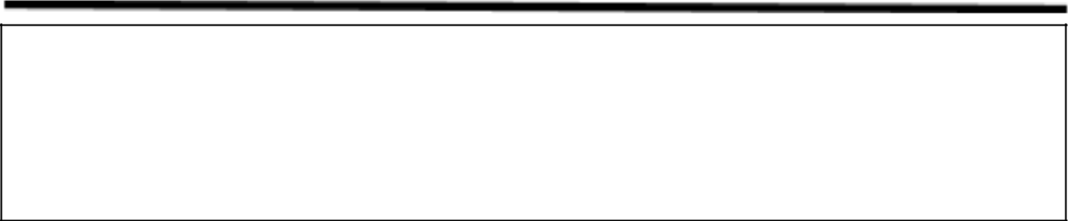

**Objective:**

* To learn to use Conditional Statements
* To learn about different types of loops (for, while, do-while)
* To​ learn about two keywords such as break, continue, and their usages
* To learn about Character Data Type and the String type

**Tasks:**

1. Write a program to find the GCD (Greatest Common Divisor) of two numbers.

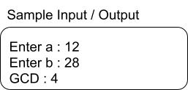

1. Generate random integers between 5 and 20 (inclusive). Use for loop to print all integers separated by a space. To generate a random integer between min and max range:

int n = (int)(min+Math.random()*(max-min+1))

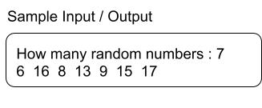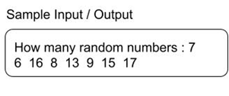

1. Write a program that checks whether a character given as input is a letter, digit or symbol.

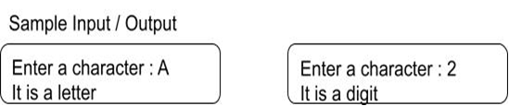

1. Write a program that prompts the user to enter two cities and displays them in alphabetical order.

**Sample Input / Output:**

